Renovation Budget and Checklist
The Renovation Checklist is to help better assist in the estimation of the After Repaired Value (ARV) of a property more accurately. You do not have to fill out this form if you have your own template but the more details we are given, the better the accuracy will be in the ARV. If you have some pictures of a previous flip or a listing that will best depict the extent of renovations you plan on completing, please provide as it can be of great assistance.
Line-Items – Check yes or no to the category. If yes please provide the estimated cost and your Client Notes in Column 3 that relate to Column 2 “notes’” - THE MORE DETAIL WE ARE PROVIDED, THE MORE ACCURATE THE VALUATORS CAN BE
Interior Components
1 | 2 | 3
Category | Notes | Client Notes – Relate comments to column 1 & 2
Paint – Interior | What are you painting?  Walls, ceilings, trim, baseboards, casings? | Yes ☐ If yes, please explain below in “notes”. No ☐ Estimated Cost: $  Notes:
Ceilings | Smooth, popcorn, knockdown? | Yes ☐ If yes, please explain below in “notes”. No ☐ Estimated Cost: $  Notes:
Interior Doors/Trim/Casings | New? | Yes ☐ If yes, please explain below in “notes”. No ☐ Estimated Cost: $  Notes:
Flooring | What kind & in what rooms – LVP (living/kitchen), carpet (bedrooms), tile (bathrooms) etc. | Yes ☐ If yes, please explain below in “notes”. No ☐ Estimated Cost: $  Notes:
Kitchen | Granite/quartz/  laminate counters?  Are you doing standard (“off the shelf” “predetermined measurement”) or custom (“built to fit specific area”) cabinets?  Expand – Ikea, shaker etc. or are you painting existing cabinets?  State if removing walls for level B or C/adding island for C | Yes ☐ If yes, please explain below in “notes”. No ☐ Estimated Cost: $  Notes:  Please also highlight which kitchen layout yours will look like:  - Galley B. L- Shape C. Open  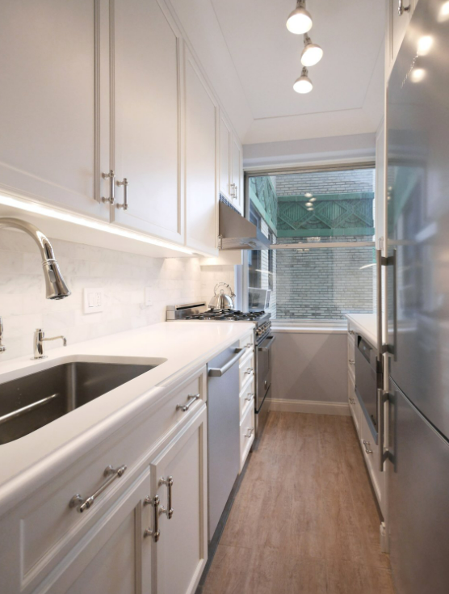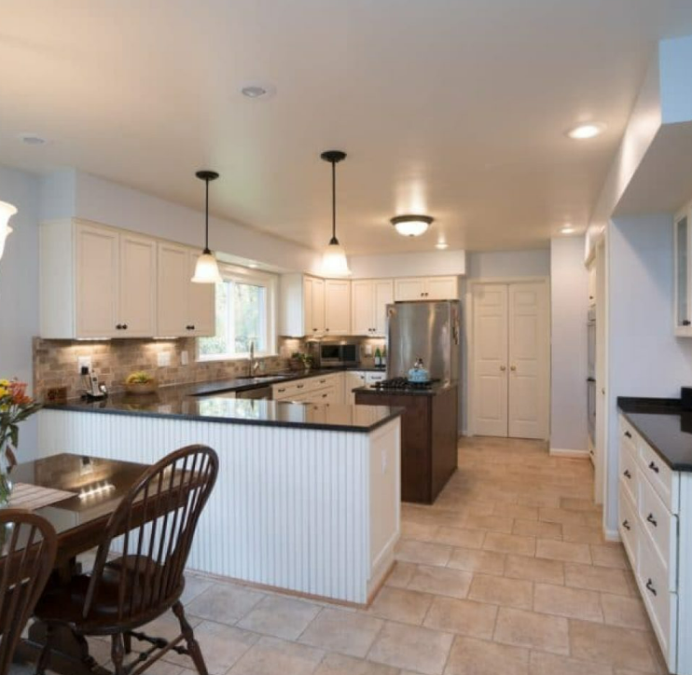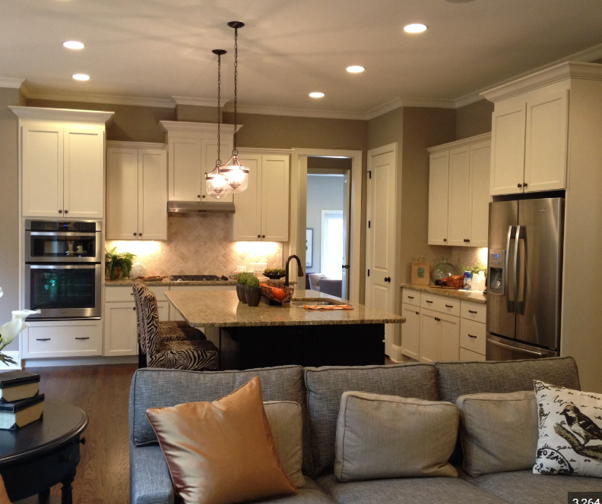  Walls on 3 sides Partially Open Open to living/dining
Appliance(s) | Built in vs stand alone? New vs used?  Stainless steel or not? | Yes ☐ If yes, please explain below in “notes”. No ☐ Estimated Cost: $  Notes:
Bathroom(s) | Granite/quartz counters or laminate?  Standard vanities? | Yes ☐ If yes, please explain below in “notes”. No ☐ Estimated Cost: $  Notes:
Plumbing Fixtures | New toilets, sinks, tubs, showers (tiles, glass?) etc. | Yes ☐ If yes, please explain below in “notes”. No ☐ Estimated Cost: $  Notes:
Lighting Fixtures | New lights throughout? Pot lights? Plates & Switches | Yes ☐ If yes, please explain below in “notes”. No ☐ Estimated Cost: $  Notes:
Upgrades | Extras added – Fireplaces, glass railings, wet bars, coffered ceilings, wood beams, in floor heat etc. | Yes ☐ If yes, please explain below in “notes”. No ☐ Estimated Cost: $  Notes:
Basement | Are you doing a Legal suite? Illegal suite? Standard finish for Single Family? Drop ceiling vs drywall? Wood panel walls vs drywall? | Yes ☐ If yes, please explain below in “notes”. No ☐ Estimated Cost: $  Notes:
Floor Plan Confirmation  BASED ON ARV | Fill out the grid based on the reno plan. | Above Grade Basement  Number Beds  Number Full Baths (3 or 4 pc)  Number Half Baths (2 pc)
Electrical Systems | New wiring, new panel?  Indicate if fuses, aluminum, knob/tube or existing circuit breakers? – if not updating | Yes ☐ If yes, please explain below in “notes”. No ☐ Estimated Cost: $  Notes:
Plumbing Systems | New supply and drain lines, new hot water tank/on demand?  Indicate if Kitec, poly-b, lead? – if not updating | Yes ☐ If yes, please explain below in “notes”. No ☐ Estimated Cost: $  Notes:
HVAC | Systems – new ventilation ducts work; new furnace; new a/c | Yes ☐ If yes, please explain below in “notes”. No ☐ Estimated Cost: $  Notes:
Drywall | If all new – are you also doing new insulation?  Repair work? | Yes ☐ If yes, please explain below in “notes”. No ☐ Estimated Cost: $  Notes:
Exterior Components
1 | 2 | 3
Category | Notes | Client Notes – Relate comments to column 1 & 2
Roof | New shingles? Repair work? | Yes ☐ If yes, please explain below in “notes”. No ☐ Estimated Cost: $  Notes:
Siding & Trim/Fascia | New or painting the existing? | Yes ☐ If yes, please explain below in “notes”. No ☐ Estimated Cost: $  Notes:
Windows/  Exterior Doors | New? Repair? | Yes ☐ If yes, please explain below in “notes”. No ☐ Estimated Cost: $  Notes:
Decks/Patios | New or Repair? Type of material if new – wood/composite/  concrete/paving tiles | Yes ☐ If yes, please explain below in “notes”. No ☐ Estimated Cost: $  Notes:
Landscaping | Clean up? | Yes ☐ If yes, please explain below in “notes”. No ☐ Estimated Cost: $  Notes:
Garage | Updates to existing?  New? - Single, Double or Triple? | Yes ☐ If yes, please explain below in “notes”. No ☐ Estimated Cost: $  Notes:
Addition/  Structural Changes/  Framing | Fill out the table: | Yes ☐ If yes, please explain below in “notes”. No ☐ Estimated Cost: $  Notes:  Addition Yes ☐ No ☐  Size of Addition - sq ft  Addition built on a full Bsmt Yes ☐ No ☐  Addition built on concrete slab Yes ☐ No ☐  What is it? – living room? Bedroom?  Attached Garage conversion Yes ☐ No ☐  Size of garage - sq ft  what will it be? – living room? Bedroom?
Other: |  | Yes ☐ If yes, please explain below in “notes”. No ☐ Estimated Cost: $  Notes:
Total Budget  Does this include labour? |  | $  Yes ☐ No ☐

